Summer Term Week 3 homework

Reading: To be done every day
https://home.oxfordowl.co.uk/reading/
This website allows you to access the reading books according to your child’s book band colour. You have to click on ‘Free eBook library' in the reading section. Then click on ’Levels' to access books according to RWI book bands. For example, if your child is reading a red RWI book, you can choose the same colour book for your child to read. This site can also be used for maths
Phonics: To be done every day
https://www.ruthmiskin.com/en/find-out-more/help-during-school-closure/
Read Write Inc, which is the scheme we use at school, is conducting phonic lessons on YouTube and Facebook for children to learn at home. Here are the times of the live streaming.
Please ensure that you watch them daily.
Give your child some words to write that use the sound they have just learned.
Speed Sounds Set 1 - for children in Nursery and Reception and children who are new to English
- Set 1 Speed Sounds 9.30 am (BST)
- Set 1 Word Time 9.45 am
- Set 1 Spelling 10.00 am
Speed Sounds Set 2 - for children in Reception that can read Set 1 Speed Sounds and for children in Year 1 and 2
- Set 2 Speed Sounds and Word Time 10.00 am
- Set 2 Spelling 10.15am
Speed Sounds Set 3 - for children in Year 1 and 2 that can read Set 2 Speed Sounds
- Set 3 Speed Sounds and Word Time 10.30 am
- Set 3 Spelling 10.45 am
Maths
Adding and subtracting
Work with your child to count real life objects. They should understand that the quantity of the group changes as you add more.
Say to your child: Show me 5 fingers. Now show me 2 more. How many fingers are there now? How do you know there are 7? Did you count them all (1,2,3,4,5,6,7) Is there another way to count? (We know there are 5 on this hand so we don’t need to count these from 1. We can start counting on from 5 – 5,6,7)

Try another one: Show me 5 fingers. Now show me 4 more. How many fingers are there now? How do you know? Keep practising so that your child understands that they don’t need to count from 1 every time. They know there are 5, so start counting on from 5 every time.

Now tell a Maths story. Eg. First there are 2 people on the bus. Then 2 more people get on. Now there are __ people on the bus.
Encourage your child to use physical objects to work out the answers.
Tell another story. Eg. First there are 3 dinosaurs in the swamp. Then 1 more dinosaur joint them. Now there are __ dinosaurs in the swamp.

As you tell the Maths stories, make sure you use the language ‘first’, ‘then’ and ‘next’.

Take a photo of the objects that you have used to create your Maths stories to stick in your green book. Or you could draw pictures of your Maths stories in your green book.

Writing
Animals
Read these ‘What Am I?’ poems to your child:
Can you think of an animal and write a ‘What Am I?’ poem.

First think of an animal.
Then write down some words and ideas about your animal.
Put them into sentences starting with the word I ___
You only need to think of 3 or 4 sentences and then end with the question ‘What Am I?’

Write your poem in your green book.

Read the poem to another member of the family. Can they guess what the animal is based on your description?

Remember you don’t have to write the whole poem in one day.

Understanding the world
Animals
Remind your child of the learning they did last week on farm animals. Can they name any?
Now think about wild animals. Can they name any wild animals? What’s the same and different about farm animals and wild animals?

Wild animals live in the forest. They can find their own food and shelter. Farm animals live on farms and the farmer looks after them. They give us milk, eggs and meat.

Look at the video on wild animals
https://www.youtube.com/watch?v=EeaDowUYtks

Last week, your child drew and labelled a farm animal. This week, can they make a model of a wild animal, using any modelling materials you have to hand.

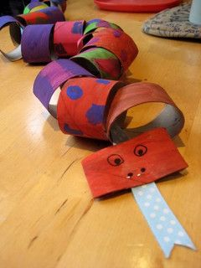
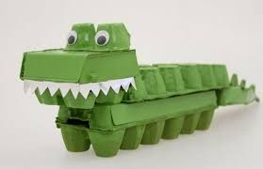
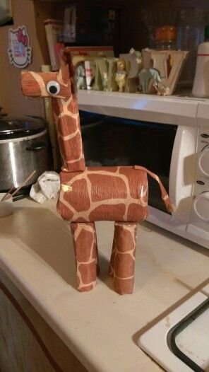

Can your child create a jungle/savannah/desert and place their model in the correct environment?
Take a photo of their model and stick it into their green book.

Purple Mash
Animal homes
Watch the below videos on animals and their homes.

https://www.youtube.com/watch?v=r_Fnk7dGq8U
https://www.youtube.com/watch?v=JuHg5oWF_mo

Go to Purple Mash and look in the ‘2Do’ section for your task. If you can’t find it, look in the ‘Alerts’ section. Your task is to write about animals and their homes. You can select pictures of animals and write about where they live. You can do your writing in the brown boxes. Make sure you sound out and write the words yourself. Your parents can help you in finding the right key on the keyboard but you have to do the writing all by yourself.

This needs to be handed in by 11th May to be marked.

Other Useful Websites:
1. https://www.topmarks.co.uk/maths-games/3-5-years/counting
2. https://new.phonicsplay.co.uk
3. https://www.twinkl.co.uk/home-learning-hub
4. https://whiterosemaths.com/homelearning/early-years/
(This is an excellent resource and is the scheme of learning that we use in school for Maths learning. Please give some of their ideas a go!)
5. PE with Joe – search for this on YouTube for your daily PE
lesson. It is great fun and would be good for the whole
family!!

