Year 5
Spring 2: School Closure
Week 2
Dear Parents/Carers,
Thank you to the children who have sent me their ‘Shang Dynasty’ PowerPoint presentation. Well done! When you have completed a task and you would like me to mark it, you can email your work to me and I’ll do my best to reply, sid@sydneyrussellschool.com
In order to keep fit and active, use the Jo Wick PE lesson, which is streamed live every morning from 9am. I’m doing it with my family- why not join in. Enjoy the rest of the week and keep safe.
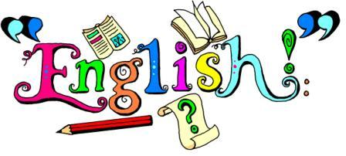 | Read your book for at least 20 minutes every night and get your reading record signed.  Revisit all your spelling so far and the Year 5 spring list.  Purple Mash – The Magic Pen.  Read Chapter 2 and complete the activities to go with this book on Purple Mash. There are lots of books with follow up activities that you can do on PurpleMash.  You can also go on Oxford Owl  Class login:-Orchidclass  Password:-SRSP  I have given you a SPAG test to also complete – parents I have also added the answer sheet for you.
Practise your multiplications by visiting ‘Hit The Button’ website. There’s work on Prodigy and Purple Mash for you to do.
Complete the fraction and decimal sheet attached.
Use the website below to practice converting fractions and decimals.
https://www.education.com/exercise/convert-decimals-to-fractions/
Product a fact sheet about the Shang Dynasty. Use as many resources as you can find including pictures. You can also do a PowerPoint presentation which you can email to me at:-
sid@sydneyrussellschool.com
Growing and Changing
On a separate sheet or in your homework book, cut out the pictures and sort into women and girls.

