School Work Pack
Print this page or write the activities for the week on the front page. Use these boxes below to get your child to self assess their work every day. (SA: Self assessment PA: Parent assessment)
Day | Activities (WC: 15th June 2020)  (Please do not print any worksheets you can simply write the answers in your book) | SA | PA
Monday  Please remember to exercise for at least 30 minutes per day. | Maths: https://vimeo.com/425603587  https://resources.whiterosemaths.com/wp-content/uploads/2020/05/Lesson-1-Find-a-rule-two-step-2019.pdf  Topic (Science): LI: I will be able to show what I know about light.  Task: Consider both scenarios, write and explain your answers clearly in your book. Use diagrams if you need to. Then complete the sentence to finish off.  1. Consider the below scenario about the cave. All of the statements are correct.  - Explain the reasons behind what the characters are saying, how do you know they are correct?  - Imagine you are the fourth character- would you decide to take the torch with you or not? Explain when you would need the torch in the cave and why.  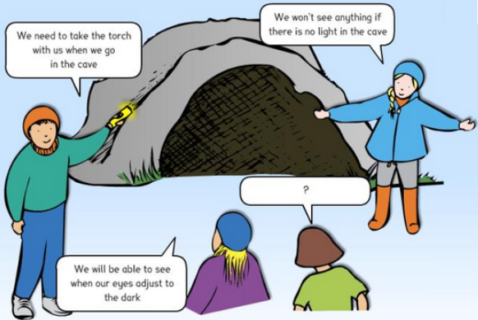  2. Think about the below scenario about the tree. Only one of the statements are correct. Go outside and observe the shadow of a tree on a sunny day, consider each statement.  - Which character is correct? Explain your answer with reasoning.  - Which characters are incorrect? Explain your answer with reasoning.  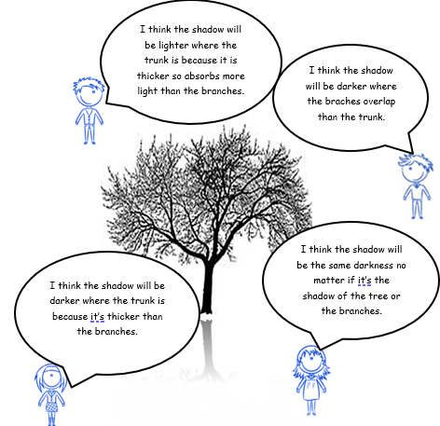  Copy and complete these sentences in your book:  To be able to see, we need ____________.  When there is no light there is __________.  We cannot see at all when there is total ___________.  When the ________ from a light source is blocked by a solid object, a ___________is formed.  Literacy: Our Big Kitchen:  Read the first chapter. Access it from: https://www.purplemash.com/mashcontent/applications/serialmash/our_big_kitchen_ch1/ch1/our_big_kitchen_ch1.pdf  (This task will show up in your child’s ‘2dos’ section)
Tuesday  Ensure a good daily sleeping routine | Maths: https://vimeo.com/425603866  https://resources.whiterosemaths.com/wp-content/uploads/2020/05/Lesson-2-Forming-expressions-2019.pdf  Topic (History: Britain after 1948)  LI: I will be able to identify similarities and differences between types of sources of information available in different periods in the past  There are two different types of historical sources: PRIMARY and SECONDARY sources.  Primary Sources  A primary source is one that was written or created during the period that is being studied. It shows an inside look at what a person, event or period was like. Primary sources include: diaries, speeches (written or recorded), letters, interviews, ofﬁcial records, autobiographies, art, clothing, pottery and photographs.  Secondary Sources  Secondary sources are created after the period that is being studied. They interpret primary sources by looking at the evidence presented and drawing conclusions about what a person, event or period was like. The most common form of a secondary source is a textbook, but other secondary sources include magazine articles and biographies  History Task ( to be completes in your book) :  - List the following sources  - Decide if they are primary or secondary?  - Discuss what kind of information we can find out from each source  SOURCES:  - Portrait of Sir Francis Drake, 1580  - Inventory of possessions, 1698  - TV interview with Tony Blair on election night, 1997  - Letter from Queen Victoria to the Duke of Wellington, 1851  - Magazine article about Charles I, written in 2010  - Biography of Mozart, published 2006  - “The Vikings” textbook, published 1992  - Autobiography of Mahatma Gandhi, 1920s  - Vintage 1950s cotton dress  - Ancient Greek vase, c. 520 BC  - Pride and Prejudice, novel written 1797  - Birth certificate of Barack Obama, 1961  Literacy LI: I will be able to review my reading by recapping events in the story. Complete the MCQ and chapter related activities. Access it from:  - https://static.purplemash.com/mashcontent/applications/serialmash/our_big_kitchen_ch1_MultipleChoice/OurBigKitchen_Ch1_CQ.pdf  - Go through and read the slide show. Access it from: https://www.purplemash.com/#app/bloglinks/ourbigkitchen_slideshow  - Survey your family and friends and create a pie chart. Access it from: https://www.purplemash.com/#app/bloglinks/ourbigkitchen_2graph_biscuits  The MCQ task, the slideshow and the pie chart activity will show up in your child’s ‘2dos’ section)
Wednesday  Have a balanced and healthy diet. | Maths: https://vimeo.com/425603939  https://resources.whiterosemaths.com/wp-content/uploads/2020/05/Lesson-3-Substitution-2019.pdf  Topic (Art): LI I will be able write about the life of L.S. Lowry.  Task: Research and write about L.S. Lowry and what he was best known for. Include information about his birth, early life, later life, art work and death. Write about which of his art pieces became famous; include art examples from your research.  (This task will show up in your child’s ‘2dos’ section)  Literacy: LI: I will be able to use text evidence to prove and explain my answer. Complete the Open Ended Questions activity. Access it from: https://static.purplemash.com/mashcontent/applications/serialmash/our_big_kitchen_ch1_OpenEnded/OurBigKitchen_Ch1_OpEnd.pdf  The open ended questions activity will show up in your child’s ‘2dos’ section)
Thursday  Setup a quiet area for learning. | Maths: https://vimeo.com/425605040  https://resources.whiterosemaths.com/wp-content/uploads/2020/05/Lesson-4-Solve-simple-one-step-equations-2019.pdf  Topic (R.E/PSHE): LI: I will be able to explore and discuss the story of Joseph.  The story of Joseph and his dreams, his coat, his brothers and his rescue of the Egyptian people runs from Genesis 37 and 39-42.  - Watch and listen to the story of Joseph:  https://www.youtube.com/watch?v=THw7uNkHppM  - In your book :  - Write about two of the most important moments or characters in the story.  EMOTION WORDS: pride, boasting, jealousy, fear, anger, despair, determination, inspiration, relief, delight, worry, joy, anxiety  - Choose ‘emotion’ words from above that describe ‘ups and downs’ of Joseph’s experiences. Write down at what Joseph was experiencing when he felt those emotions  - Despite the difficulties he faced, Joseph was strong because he strongly believed in God. Write about a difficult experience in your life when you really needed to be strong. What helped you to be strong?  Literacy: LI: I will be able to complete SPAG questions and complete the spreadsheet related to the chapter I have read.  - Complete the SPAG activity Access it from: https://static.purplemash.com/mashcontent/applications/serialmash/our_big_kitchen_ch1_SPaG/OurBigKitchen_Ch1_SPaG.pdf  - Calculate and plan your food budget . Access it from:  https://www.purplemash.com/#app/tools/2Calculate_budget_planner  - Calculate and plan your meal for five people. Access it from:  https://www.purplemash.com/#app/pup/our_big_kitchen_budget_planner  The SPaG task and the planning activities will show up in your child’s ‘2dos’ section)
Friday  Praise and reward your child’s hard work to keep them motivated and engaged. | Maths: Times tables practice on Purple mash (This task will show up in your child’s ‘2dos’ section)  https://www.purplemash.com/#app/games/timestables_adaptive)  Topic (Spellings): Task (words ending in _ant): Please learn these spellings and write a sentence for each word.  observant, expectant, hesitant, tolerant, triumphant, dominant, contestant, defiant, decongestant, relevant  Topic (Music): Task:  This week you are going to continue listening to music in the Twentieth Century from 1900 onwards. Lots of different and exciting things started happening in the twentieth century which led to the development of lots of different styles of music.  This week you are going to listen to two pieces by Stravinsky.  Click on the link below which will take you to a page on the BBC Ten Pieces website:  https://www.bbc.co.uk/teach/ten-pieces/classical-music-primary-igor-stravinksy-firebird-ks2/zbsf3k7  1. WATCH – Claudia Winkleman introduces Stravinsky's ‘The Firebird’.  2. READ the information about the piece.  3. READ about the composer Igor Stravinsky.  4. WATCH – The full orchestral performance of Stravinsky’s piece ‘The Firebird’ from BBC NOW.  Now click on the link below and listen to some of the music from ‘The Rite of Spring’ by Stravinsky. You don’t need to listen to the whole piece, the first 7 or 8 minutes is enough. Stravinsky composed ‘The Rite of Spring’ in 1913, two years after ‘The Firebird’ and you can hear how his music has stated to sound quite different. The melodies are less clear and you can hear more clashing notes or dissonance. When ‘The Rite of Spring’ was first performed, the audience were so annoyed about Stravinsky’s music that a riot broke out in the theatre!!!  ’Literacy: LI: I will be able to write a personification poem about hunger.  Write a poem about hunger as if it is a monster that grows inside people – you do not need to make your poem rhyme.  Include the stages and growing urgency of your hunger; how it feels when hunger is overcome; a hunger colour; the sound, taste and fell of hunger; how hunger controls you and how you control hunger; how you can distract from feeling hunger.  (This task will show up in your child’s ‘2dos’ section)
Extra information:
Please access all of the maths learning videos by following this link:
https://whiterosemaths.com/homelearning/year-6/
To access the answers for reading activities please visit:
https://static.purplemash.com/mashcontent/applications/serialmash/our_big_kitchen_ch1_AllTeachingRes/OurBigKitchen_Ch1_TR.pdf
For any questions regarding your child’s work please email your child’s class teacher direct at :
Mrs Choudhry: shc@sydneyrussellschool.com

