School Work Pack
Print this page or write the activities for the week on the front page. Use these boxes below to get your child to self assess their work every day. (SA: Self assessment PA: Parent assessment)
Day | Activities (WC: 29nd June 2020)  (Please do not print any worksheets you can simply write the answers in your book) | SA | PA
Monday  Please remember to exercise for at least 30 minutes per day. | Maths: https://vimeo.com/430339457  https://resources.whiterosemaths.com/wp-content/uploads/2020/06/Lesson-1-Area-and-perimeter.pdf  Topic (Science): LI: I will be able to investigate what affects the size of a shadow  FOR THIS LESSON, YOU WILL NEED:  - a torch  - a large piece of white paper  - tape measure/long ruler  - card cut into a 2-D shape (square or triangle)  Last lesson, we proved the idea that light travels in straight lines. That is why shadows have the same shape as the objects that cast them.  Think about when you see the shadow of an object (or yourself) in the sun, I am sure you have noticed that the size of the shadow changes, sometimes more/less wider and other times more/less longer. We know this happens because of the changing the position of the sun relative to the Earth. Why does the size of the shadow change?  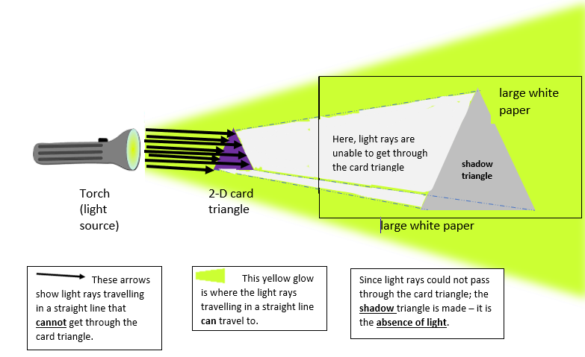  This diagram shows the test you will do to find out what affects the size of a shadow:  Control variables (kept the same for a fair test):  - the paper  - the 2-D shape  - the torch  - the distance between the 2-D shape and the paper  Independent variable (changed for the investigation)  - the distance between the torch and the paper  Dependent variable (results from the investigation)  - the size of shadow  YOUR TASK:  INVESTIGATE  - How can we change shadow size?  - Is there a relationship between the light source’s distance from the object and shadow size?  IN YOUR BOOK:  - Write your Hypothesis (Respond to the ‘investigate’ Qs: I predict that…)  - Write your Method (what you will do to test your hypothesis)  - Draw a Diagram like the one above (so that anyone can follow your method easily)  INVESTIGATE continued (using the card shape, torch, white paper, ruler):  - What happens to the size of the shadow when you increase the distance between the torch and the card shape?  - What happens to the size of the shadow when you decrease the distance between the torch and the card shape?  - Is there a pattern in the results that shows the relationship between the light source’s distance from the object and shadow size?  IN YOUR BOOK:  - Write your Results (what did you find happened? Draw a table to show the change in the shadow height when torch-object distance was changed (use cm as your unit of measure)  - Accurately plot your results on a line graph with an appropriate scale and labels  - Write your Conclusion:  - Was your hypothesis prediction correct? How do you know?  - In what way was your investigation good? Give reasons for your answer.  - What could you have done to make the investigation even better? Give reasons for your answer.  Literacy: Our Big Kitchen:  Read the second and third chapter. Access them from:  - https://www.purplemash.com/mashcontent/applications/serialmash/our_big_kitchen_ch3/ch1/our_big_kitchen_ch3.pdf  - https://www.purplemash.com/mashcontent/applications/serialmash/our_big_kitchen_ch4/ch1/our_big_kitchen_ch4.pdf  These tasks will show up in your child’s ‘2dos’ section
Tuesday  Ensure a good daily sleeping routine | Maths: https://vimeo.com/430339609  https://resources.whiterosemaths.com/wp-content/uploads/2020/06/Lesson-2-Area-of-a-triangle-3.pdf  Topic (History: Britain after 1948) LI: I will be able to find out some of the main events of the 1960s and to investigate what life was like during this period.  **first go through the ‘HISTORY LESSON 4’ slides that are on Purple Mash**  These slides will show up in your child’s ‘2dos’ section  History Task (to be completed in your book):  - In your book:  - Use the information you have found out about the Swinging Sixties (from the slides uploaded to Purple Mash)  - Your task is to design and create a poster that shows why the 1960s are referred to as the Swinging Sixties.  - Your poster should:  - Have a bold title and sub-headings for different sections  - include labelled pictures and short explanations  - Make it colourful, vibrant and exciting – like the 1960s were!  - Include references to fashion, music, youth attitudes, etc.  Literacy LI: I will be able to recap events in the story and writing a first-person description  Complete the MCQ and chapter related activities. Access from:  - https://static.purplemash.com/mashcontent/applications/serialmash/our_big_kitchen_ch3_MultipleChoice/OurBigKitchen_Ch3_CQ.pdf  - https://static.purplemash.com/mashcontent/applications/serialmash/our_big_kitchen_ch4_MultipleChoice/OurBigKitchen_Ch4_CQ.pdf  - Use the prompts below to write a first-person description of what home means to you.  - a place you call home  - sounds  - smells  - furniture  - feelings  - memories  - details  - people  There are further ‘food’ activities in Purple Mash, set as ‘ 2Dos’.  The MCQ task, the writing activity and the food activities will show up in your child’s ‘2dos’ section
Wednesday  Have a balanced and healthy diet. | Maths: https://vimeo.com/430339748  https://resources.whiterosemaths.com/wp-content/uploads/2020/06/Lesson-3-Area-of-a-parallelogram.pdf  Topic (Art):  LI: I will be able to develop ideas for an abstract work of art inspired by Kandinsky  - Wassily Kandinsky was trying to develop a ‘language’ for art: a way of showing the five senses, ideas and feelings using colours, shapes and patterns  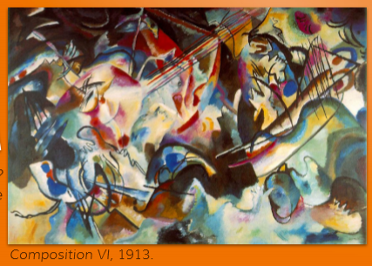  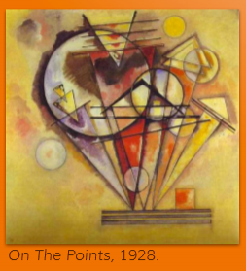  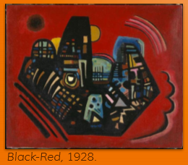  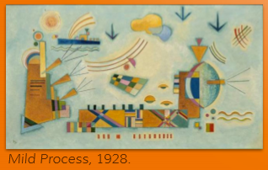  - Kandinsky said that he saw colours and shapes when he heard certain sounds, or music; he was inspired by music, and used shapes and colours to express the sounds made by instruments of an orchestra.  Look at the above examples of Kandinsky’s paintings.  - What can you see?  - What do you think about these paintings?  - What effect do the shapes and colours have?  - Do parts of them remind you of certain sounds, or music?  - How do they make you feel?  Task:  - Think back to a situation in which you have felt frustrated.  - Consider ways in which you could represent your feelings in a work of art  - Using Kandinsky’s style of lines, 2-D shapes and patterns, sketch, colour and annotate your ideas for a piece of abstract art to show your feelings  - Evaluate: Write, with reasoning, what works well and what you will change when you make your final piece of art.  Literacy: LI: I will be able to use text evidence to prove and explain my answer. Complete the Open-Ended Questions activities. Access them from:  - https://static.purplemash.com/mashcontent/applications/serialmash/our_big_kitchen_ch3_OpenEnded/OurBigKitchen_Ch3_OpEnd.pdf  - https://static.purplemash.com/mashcontent/applications/serialmash/our_big_kitchen_ch4_OpenEnded/OurBigKitchen_Ch4_OpEnd.pdf  The open-ended questions activities will show up in your child’s ‘2dos’ section
Thursday  Setup a quiet area for learning. | Maths: https://vimeo.com/430339843  https://resources.whiterosemaths.com/wp-content/uploads/2020/06/Lesson-4-Volume-of-a-cuboid.pdf  Topic (PSHE):  - I have attached a table of activities at the end of this document  - While you are working from home, try and complete AS MANY of these as possible  - As you complete the activities, write the date or colour in the box to help you keep track. You can paste any photos/links to your work into a PowerPoint document and email it to me shc@sydneyrussellschool.com  - If you will not be making a PowerPoint, you can still email me details of what you are doing.  (R.E): LI: I will be able to consider how faith can influence how we respond to ultimate questions about the purpose of life’.  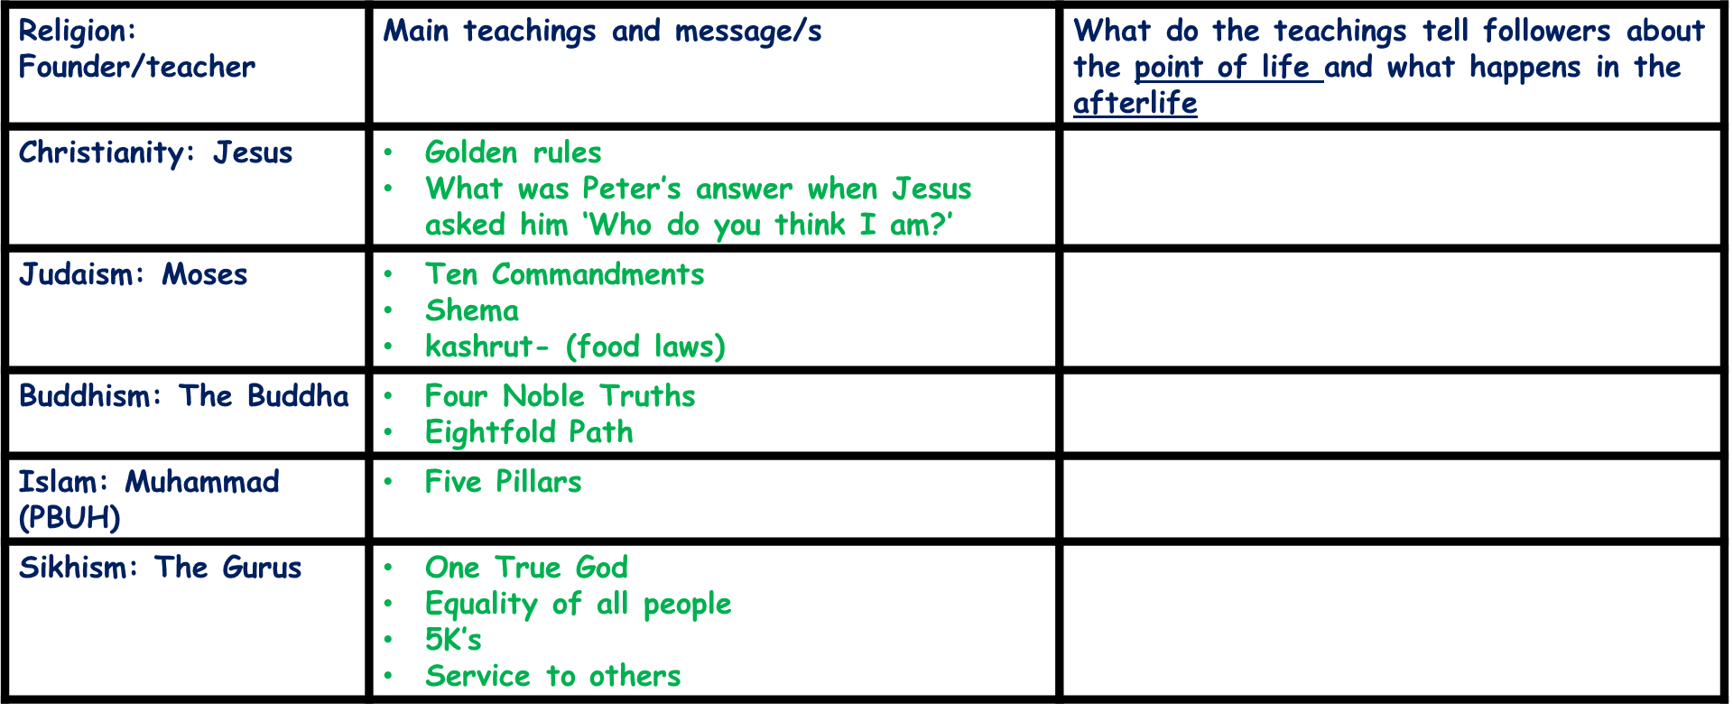  IN YOUR BOOK:  - Copy this table to research and record key teachings of the main world religions.  - DO NOT copy the second column, these bullet points are to guide you through your research  - In the third column, suggest how the teachings may help to answer ultimate questions about the purpose of life and beyond.  FINAL THOUGHTS. COPY AND COMPLETE THESE SENTENCES IN YOUR BOOK:  - I am inspired by the key teaching from …  - I think the purpose of life is…  - For my future, I hope I can…  Literacy: LI: I will be able to complete SPAG questions and write a personal account related to the chapter I have read.  Complete the SPAG activities Access from:  - https://static.purplemash.com/mashcontent/applications/serialmash/our_big_kitchen_ch3_SPaG/OurBigKitchen_Ch3_SPaG.pdf  - https://static.purplemash.com/mashcontent/applications/serialmash/our_big_kitchen_ch4_SPaG/OurBigKitchen_Ch4_SPaG.pdf  Write a thoughtful personal account of how you could make a difference to the world. Consider how you could ‘make a difference’:  - at home  - with your neighbours  - in the playground  - with your classmates  - by donating  - by behaving safely online  - by caring for the environment  The SPaG tasks and the ‘make a difference’ writing task will show up in your child’s ‘2dos’ section
Friday  Praise and reward your child’s hard work to keep them motivated and engaged. | Maths: Times tables practice on Purple mash  This task will show up in your child’s ‘2dos’ section  https://www.purplemash.com/#app/games/timestables_adaptive)  Topic (Spellings): Task (statutory words): Please learn these spellings and write a sentence for each word.  identity, immediate, immediately, individual, interfere, interrupt, language, leisure, lightning, marvellous, mischievous, muscle, necessary  Topic (Music): Task:  This week you are going to continue listening to music in the Twentieth Century, from 1900 onwards. Lots of different and very exciting things started happening in the twentieth century which led to the development of lots of very different styles of music.  This week’s piece is particularly important as it was composed in 1933 by Florence Price who was the first black, female composer to have her work performed by a major symphony orchestra. Look out for the use of djembe’s in the percussion section!  Click on the link below which will take you to a page on the BBC Ten Pieces website:  https://www.bbc.co.uk/teach/ten-pieces/classical-music-florence-price-symphony-no1/z48rscw  1. READ - the information about Florence Price  2. READ - the Fast Facts  3. WATCH - Naomi Wilkinson explores the West African rhythms of Florence Price’s Symphony No.1.  4. READ the information about ‘Juba Dance’  5. WATCH - the full performance of Price’s piece.  Literacy:  LI: I will be able to write a newspaper report about a community kitchen.  Write a newspaper report about Our Big Kitchen or a local community kitchen near you.  Organise your writing into paragraphs and proof read everything to make sure it flows to make sense. Make sure sentences are well punctuated and vary in length.  Your report should include:  - Who the report is about; who is involved; who the kitchen supports  - what the community kitchen is; what it does; what it believes in  - When the idea began; when the kitchen was established  - Where the community kitchen is located; where the meals are made  - How the community kitchen helps people; how it achieves sharing kindness and love with others  - Quotes from people who work in the community kitchen  Access the task on Purple Mash:  https://www.purplemash.com/#app/serialmash/OurBigKitchen_Ch2_Activity  This task will show up in your child’s ‘2dos’ section
Extra information:
Please access all of the maths learning videos by following this link:
https://whiterosemaths.com/homelearning/year-6/
To access the answers for reading activities please visit:
- https://static.purplemash.com/mashcontent/applications/serialmash/our_big_kitchen_ch3_AllTeachingRes/OurBigKitchen_Ch3_TR.pdf
- https://static.purplemash.com/mashcontent/applications/serialmash/our_big_kitchen_ch4_AllTeachingRes/OurBigKitchen_Ch4_TR.pdf
For any questions regarding your child’s work please email your child’s class teacher direct at :
Mrs Choudhry: shc@sydneyrussellschool.com
