SRS Remote Learning – overview for Monday 8th – Friday 12th February 2021
- EYFS access their daily tasks via our website www.sydneyrussellschool.com and Purple Mash
- Year 1 – Year 6: Your child should log in to Purple Mash by 9am every day to read the daily message from their teacher and begin their daily tasks.
If you have any queries please contact your child’s class teacher on Class Dojo or by calling the office on 0203 959 9901.

Click the link for guidance on how to submit work on Purple Mash: How to Submit Homework on Purple Mash! (For Students & Parents) - YouTube
 | Monday 8th February | Tuesday 9th February | Wednesday 10th February | Thursday 11th February | Friday 12th February
Assemblies | Class assembly  These will be held on Monday at 1pm.  Details will be sent via Dojo and Purple Mash. |  |  |  | Achievement assembly Zoom meeting details will be sent via Purple Mash and the Parent App (if you do not have the App please email cah@sydneyrussellschool.com and details will be sent to you).
English | Phonics:  Please watch the phonics lesson on YouTube. Follow this link: https://www.youtube.com/channel/UCo7fbLgY2oA_cFCIg9GdxtQ  If your child is reading red books, they should watch Set 1 and Set 2.  If your child is reading green, purple, pink or orange books, they should focus on Set 3.  Reading: You can re-read Chapters 1-3 of Little Red to help you in your writing.  Spellings: See 2Do on Purple Mash. Practice writing your spellings and write 3 sentences.  Reading: You can re-read Chapters 1-3 of Little Red to help you in your writing.  Writing Focus: Story Telling  Writing Task: Over the past 3 weeks, you have been reading the story of Little Red. The story is not quite finished.  Your job this week is complete the story.  Today you are going to think how you would like the story to end. Create a mind map of what you think will happen:  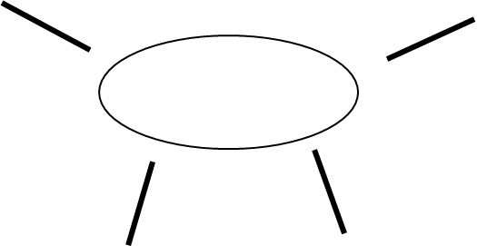  Little Red  Write your ideas as key words on your mind map. Remember for this task, you DON’T need full sentences. You can write as many words as you like.  Complete this in your green book, take a photo and upload. | Phonics:  Please watch the phonics lesson on YouTube. Follow this link: https://www.youtube.com/channel/UCo7fbLgY2oA_cFCIg9GdxtQ  If your child is reading red books, they should watch Set 1 and Set 2.  If your child is reading green, purple, pink or orange books, they should focus on Set 3.  Reading: You can re-read Chapters 1-3 of Little Red to help you in your writing.  Spellings: See 2Do on Purple Mash. Practice writing your spellings and write 3 sentences.  Writing Focus: Story writing  Writing Task: Over the past 3 weeks, you have been reading the story of Little Red. The story is not quite finished.  Your job this week is complete the story.  Use your ideas from yesterday to write the ending to the story. Remember this time, you MUST use full sentences. Think about all the SPaG lessons you have had – use capital letters, full stops, exclamation marks and maybe even a question mark.  Write this in your green book, take a photo and upload. | Phonics:  Please watch the phonics lesson on YouTube. Follow this link: https://www.youtube.com/channel/UCo7fbLgY2oA_cFCIg9GdxtQ  If your child is reading red books, they should watch Set 1 and Set 2.  If your child is reading green, purple, pink or orange books, they should focus on Set 3.  Reading: You can re-read Chapters 1-3 of Little Red to help you in your writing.  Spellings: See 2Do on Purple Mash. Practice writing your spellings and write 2 sentences.  Writing Focus: Story writing  Writing Task: Over the past 3 weeks, you have been reading the story of Little Red. The story is not quite finished.  Your job this week is complete the story.  Today you are going to check your learning. If you have a green pencil, you can use it today. (use any colour if you do not have green)  Read through your learning. Does it make sense? Are your spellings correct? Can you think of a way to make your story better? Can you add an exclamation or a question?  If you need to fix anything, cross it out with one line and write the correct word on top of the incorrect word.  If you need to add anything, write it again in green at the bottom of your piece of writing.  (This is what we do in school to correct. The children will hopefully remember!)  Take a photo of your corrected learning and upload. | Phonics:  Please watch the phonics lesson on YouTube. Follow this link: https://www.youtube.com/channel/UCo7fbLgY2oA_cFCIg9GdxtQ  If your child is reading red books, they should watch Set 1 and Set 2.  If your child is reading green, purple, pink or orange books, they should focus on Set 3.  Reading: You can re-read Chapters 1-3 of Little Red to help you in your writing.  Spellings: See 2Do on Purple Mash. Practice writing your spellings and write 2 sentences.  Writing Focus: Story writing  Writing Task: Over the past 3 weeks, you have been reading the story of Little Red. The story is not quite finished.  Your job this week is complete the story.  Today, please write your corrected learning out as a top copy. This needs to be with all the corrections included so your writing is perfect. Remember to write in your neatest writing on the line and with all the descending letters going underneath the line (q, y, p, f, g, j are all descending). Make sure that you go form the letters correctly too – common letters are a,b,d.  This may take you 2 days to complete. Only upload when completed.  Take a photo and upload. You may illustrate your ending if you wish. | Phonics:  Please watch the phonics lesson on YouTube. Follow this link: https://www.youtube.com/channel/UCo7fbLgY2oA_cFCIg9GdxtQ  If your child is reading red books, they should watch Set 1 and Set 2.  If your child is reading green, purple, pink or orange books, they should focus on Set 3.  Reading: You can re-read Chapters 1-3 of Little Red to help you in your writing.  Spellings: Complete the spelling quiz on Purple Mash/ask your parent to test you on your spellings.  Writing Task: Over the past 3 weeks, you have been reading the story of Little Red. The story is not quite finished.  Your job this week is complete the story.  Today, please write your corrected learning out as a top copy. This needs to be with all the corrections included so your writing is perfect. Remember to write in your neatest writing on the line and with all the descending letters going underneath the line (q, y, p, f, g, j are all descending). Make sure that you go form the letters correctly too – common letters are a,b,d.  This may take you 2 days to complete. Only upload when completed.  Take a photo and upload. You may illustrate your ending if you wish.
Maths | Watch this video: https://vimeo.com/500468562  When you have finished watching the video head to Purple Mash where you can find the worksheet you need to complete.  Don’t worry about printing the worksheet or writing on it on the computer. You can simply write down your answers in your homework book. When you’ve finished just upload a photo of your work to Purple Mash or ClassDojo so that we can have a look! | Watch this video: https://vimeo.com/503093120  When you have finished watching the video head to Purple Mash where you can find the worksheet you need to complete.  Please only complete Questions 1-2 today. 2-4 to be completed tomorrow.  Don’t worry about printing the worksheet or writing on it on the computer. You can simply write down your answers in your homework book. When you’ve finished just upload a photo of your work to Purple Mash or ClassDojo so that we can have a look! | Watch this video: https://vimeo.com/503098045  When you have finished watching the video head to Purple Mash where you can find the worksheet you need to complete.  Please complete Questions 2-4 today.  Don’t worry about printing the worksheet or writing on it on the computer. You can simply write down your answers in your homework book. When you’ve finished just upload a photo of your work to Purple Mash or ClassDojo so that we can have a look! | Watch this video:  https://vimeo.com/503099894  When you have finished watching the video head to Purple Mash where you can find the worksheet you need to complete.  Don’t worry about printing the worksheet or writing on it on the computer. You can simply write down your answers in your homework book. When you’ve finished just upload a photo of your work to Purple Mash or ClassDojo so that we can have a look! | Watch this video:  https://vimeo.com/503102857  When you have finished watching the video head to Purple Mash where you can find the worksheet you need to complete.  Don’t worry about printing the worksheet or writing on it on the computer. You can simply write down your answers in your homework book. When you’ve finished just upload a photo of your work to Purple Mash or ClassDojo so that we can have a look!
Wider curriculum | This Friday is Chinese New Year.  Over the course of the week, there are some fun activities that relate to this festival for you to engage in.  Today, watch the video of how the Chinese years are named.  https://www.youtube.com/watch?v=eVClAj8q_lY  This year is the Year of the Ox. Can you draw an ox and write where the ox finished the race?  You can write:  The ox finished __________. | Today, make a Chinese lantern. Watch the youtube link to help you.  If you don’t have paper, please decorate a lantern on the 2Do on Purple Mash.  You can do both if you wish!  https://www.youtube.com/watch?v=CeZKYGmuZn0 | Today, ask your grown ups to help you make some noodles to eat!  You can add vegetables, meat and sauces to your noodles. Take a photo of your delicious meal and upload to Purple Mash. | These are the Chinese numbers 1-10. Can you write them in your book?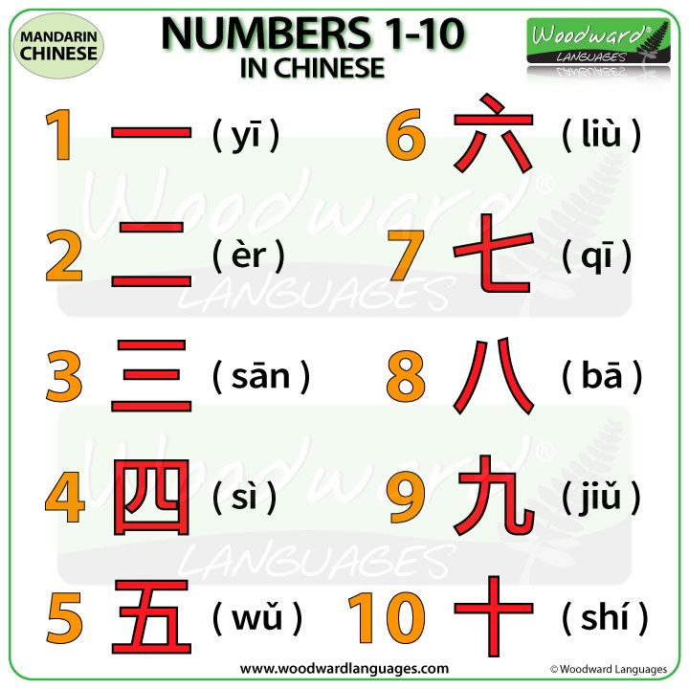 | Today you can decorate a Chinese fan on Purple Mash. Remember that red is the Chinese lucky colour.  You can wish your family Gung hay fat choy which means Happy New Year!
Reading | Your child should read every day, please keep a record in their Home Link book and remember each day of reading will count towards their next reading certificate! Please upload photos of the home link book with the reading total on weekly basis.
Exercise | Here are some tips on how your child can stay active and healthy in the week ahead:  https://justdancenow.com  Cosmic Kids Yoga - YouTube  Staying Healthy During COVID-19: Meals or Snacks? Here's a plan - Bing video

