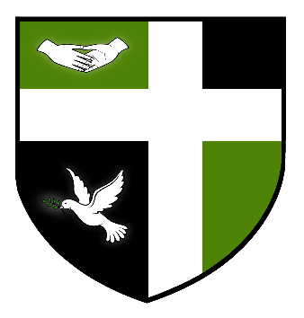

LEISURE CENTRE ASSISTANTS
FULL & PART TIME HOURS AVAILABLE
35 HOURS PER WEEK = £18,324
PART TIME HOURS = £10.04 PER HOUR
WEEKDAY EVENINGS & WEEKENDS
Sydney Russell School are seeking enthusiastic and committed Leisure Centre Assistants. There are a range of hours available, both full and part time. Please visit the school website for full details.

Sydney Russell is an over-subscribed 4-18 school serving an expanding population in an area of London which is benefiting hugely from the regeneration of the East Thames Corridor and the impact of the nearby 2012 Olympics. The school prides itself on its warm and friendly atmosphere, with positive relationships between staff and students at the centre of its success. The school was judged by Ofsted as ‘Outstanding’ in May 2013 and is amongst the top-performing schools in the country for added value.

Further details and application form are available from the school website www.sydneyrussellschool.com

The Sydney Russell School is committed to safeguarding and promoting the welfare of children and young people. We expect all staff to share this commitment and to undergo appropriate checks including enhanced CRB checks.

Closing date for applications: Friday 27th July 2017

