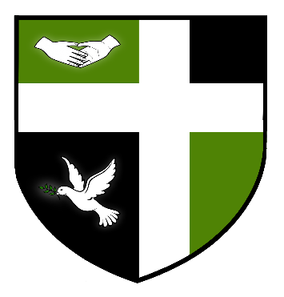

SYDNEY RUSSELL SCHOOL

EXAM INVIGILATORS

£10.20 per hour
Varying hours

We are seeking to expand our team of Invigilators, to support students during their exams. We require Invigilators to support the school with invigilation of internal and external exams. You will need to work professionally as a member of a team which ensures that regulations are followed in a supportive environment for our students to enable them to achieve their best.

The Sydney Russell School is a 4-18 school serving an expanding population in an area of London which is benefiting hugely from the regeneration of the East Thames Corridor and the impact of the nearby 2012 Olympics. The school prides itself on its warm and friendly atmosphere, with positive relationships between staff and students at the centre of its success. The school was judged by Ofsted as ‘Outstanding’ in May 2013 and is amongst the top-performing schools in the country for added value.

We are committed to safeguarding and promoting the welfare of children therefore all positions in the school will be subject to satisfactory Enhanced Criminal Records Bureau Disclosure.

Full details are available on our website. www.Sydneyrussellschool.com. Closing date for applications is Friday 16th February 2018

