SYDNEY RUSSELL SCHOOL
PRIMARY PHASE
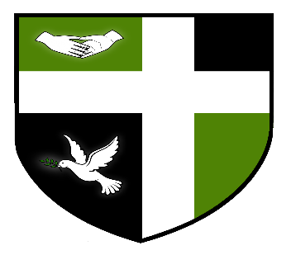

ARE RECRUITING FOR A
FULL TIME TEACHING ASSISTANT – BEHAVIOUR SUPPORT
35 HOURS PER WEEK, TERM TIME ONLY
APT& C GRADE 4 (ACTUAL SALARY £16757)

Sydney Russell School (Primary phase) is looking to appoint an enthusiastic, caring and efficient Teaching Assistant to support the behaviour team.
The person appointed will be expected to carry out a full range of duties supporting pupils with a range of behaviour needs.
A full job description and application form are available from the Sydney Russell School website. Closing date for applications is Friday 24th March 2017.

