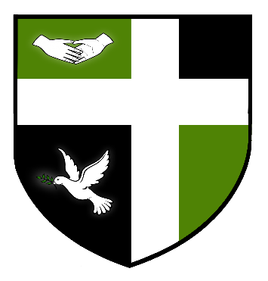

SYDNEY RUSSELL SCHOOL

RECEPTIONIST/ADMINISTRATIVE ASSISTANT

£21,154 Term Time Only
40 hour week contract

We are seeking a professional and outstanding Receptionist/Administrative Assistant to work as front of house at the Secondary School site. You will be expected to be friendly, highly professional with a helpful, welcoming and caring approach.

This post will include some school holiday working when students are on site for revision and intervention, this will be agreed in advance and pay will be in addition to the above salary.

The Sydney Russell School is a 4-18 school serving an expanding population in an area of London which is benefiting hugely from the regeneration of the East Thames Corridor and the impact of the nearby 2012 Olympics. The school prides itself on its warm and friendly atmosphere, with positive relationships between staff and students at the centre of its success. The school was judged by Ofsted as ‘Outstanding’ in May 2013 and is amongst the top-performing schools in the country for added value.

We are committed to safeguarding and promoting the welfare of children therefore all positions in the school will be subject to satisfactory Enhanced Criminal Records Bureau Disclosure.

Full details are available on our website. www.Sydneyrussellschool.com. Closing date for applications is Friday 8th June 2018.

