SYDNEY RUSSELL SCHOOL
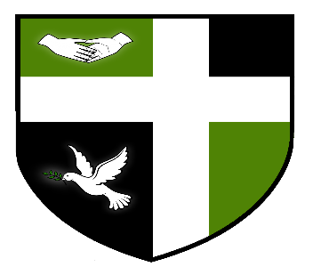

FULL & PART TIME LEARNING SUPPORT ASSISTANTS
APT& C GRADE 4

Sydney Russell School is looking to appoint enthusiastic, caring and efficient Full & Part Time Learning Support Assistants to join our team. The part time posts will be based at the Primary School, 8.30 am – 12.30 pm every day. Full time positions will be 35 hours per week.
Staff will be expected to carry out a full range of duties supporting pupils with a range of needs across the school.
A full job description and application form are available from the Sydney Russell School website. Closing date for applications is Friday 24th August 2018. Interviews will be held Friday 31st August 2018.

