AQA GCSE Combined Science: Trilogy 8464, 601/8758/X

AQA GCSE Biology 8461, 601/8752/9

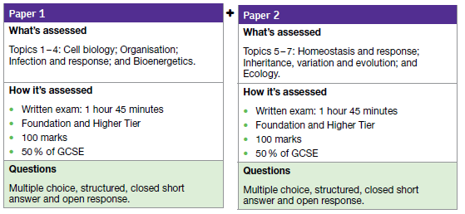

AQA GCSE Chemistry, 8461, 601/8757/8

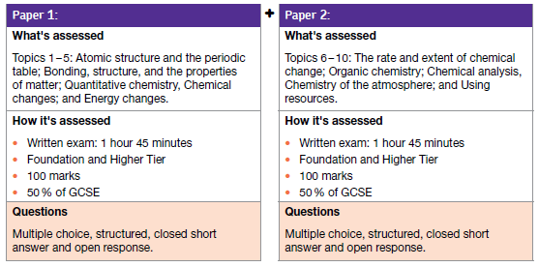

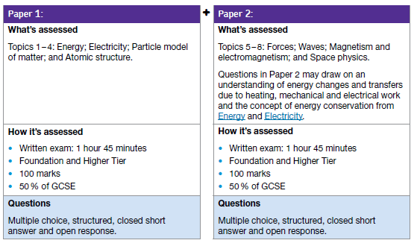
AQA GCSE Physics, 8461, 601/8751/7

