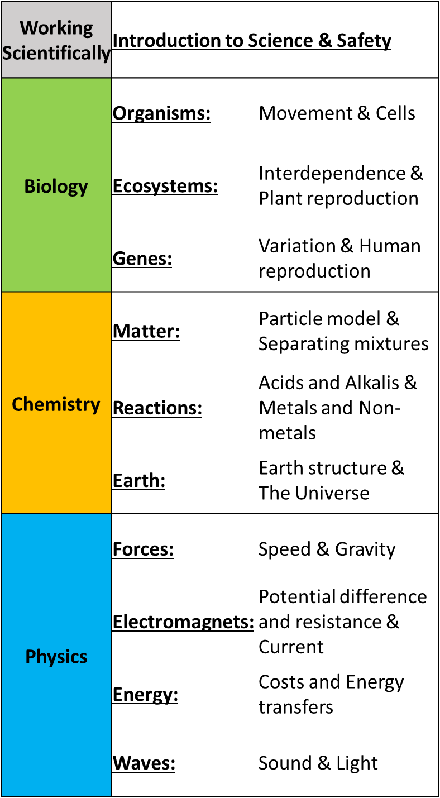
Key Stage 3 Science

Year 7
Introduction to Science & Safety

Skills that you will acquire
-Engaging hands on practical experience of Science
-Embed knowledge and skills needed to progress and succeed onto GCSE course
-Develop essential Working Scientifically skills

Further Study
Year 7 Science students will progress onto the second year of the KS3 Science course, in which they will further explore different aspects of Science.
Key Stage 3 Science

Year 8
Introduction to Enquiry Process

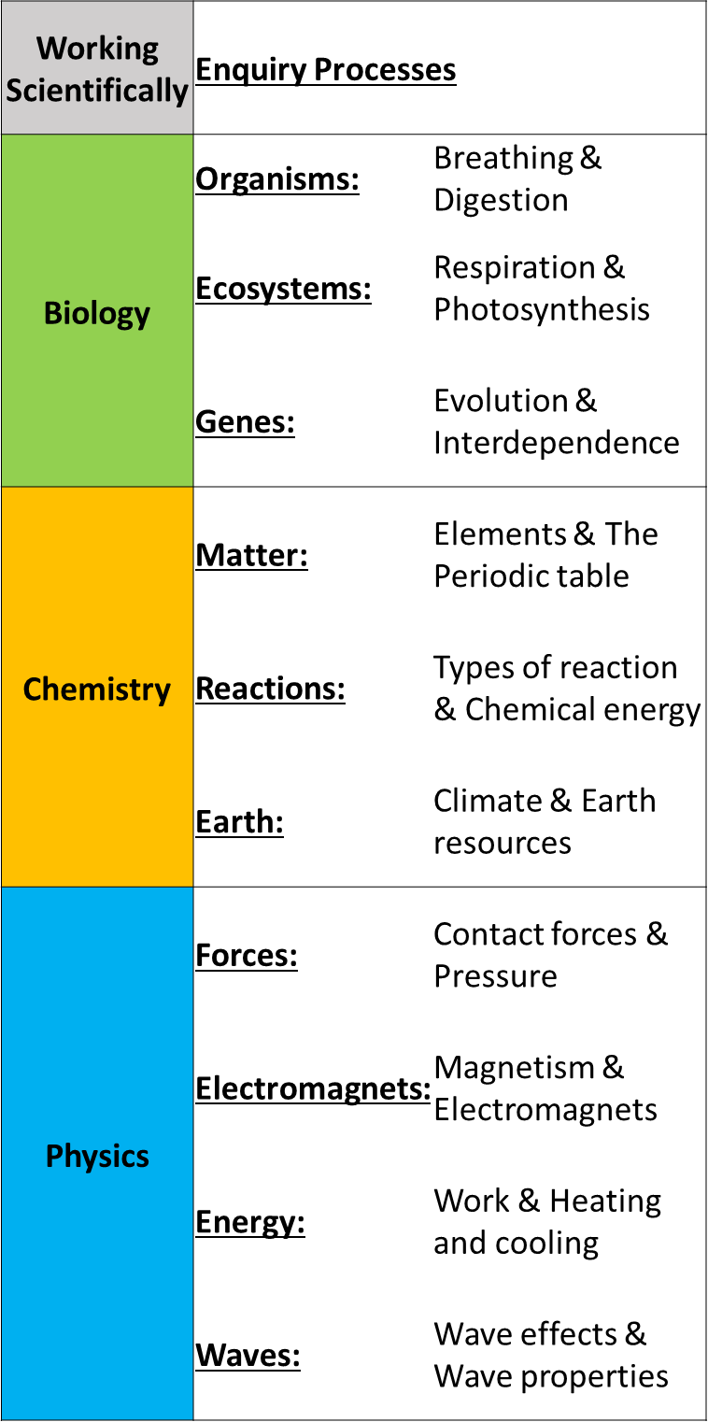
Skills that you will acquire
-Engaging hands on practical experience of Science
-Mastery of subject specific terminology, problem solving skills, and maths skills needed to progress and succeed onto GCSE course
-Develop Working Scientifically skills

Further Study
Year 8 students can choose to follow the Separate Sciences GCSE course, or the Combined Science GCSE course.
Both routes are a natural progression that allow for students to further expand upon their knowledge gained at KS3.

