KS3 – Science

Tasks & Activities
Start by reading the textbook pages and answering all of the questions, then try the tasks.
The answers can be found towards the end of the section.

Textbook Page 1
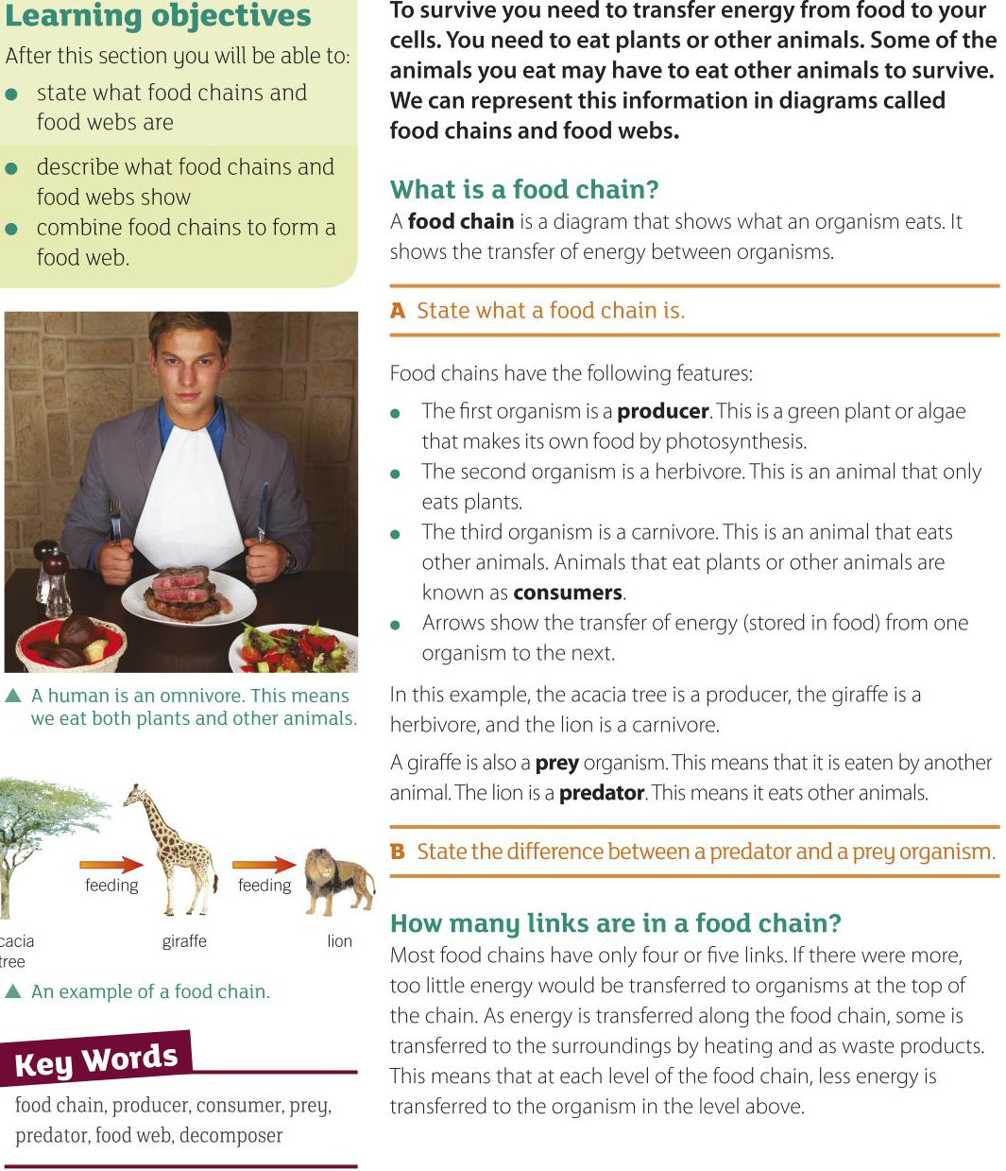

Textbook Page 2
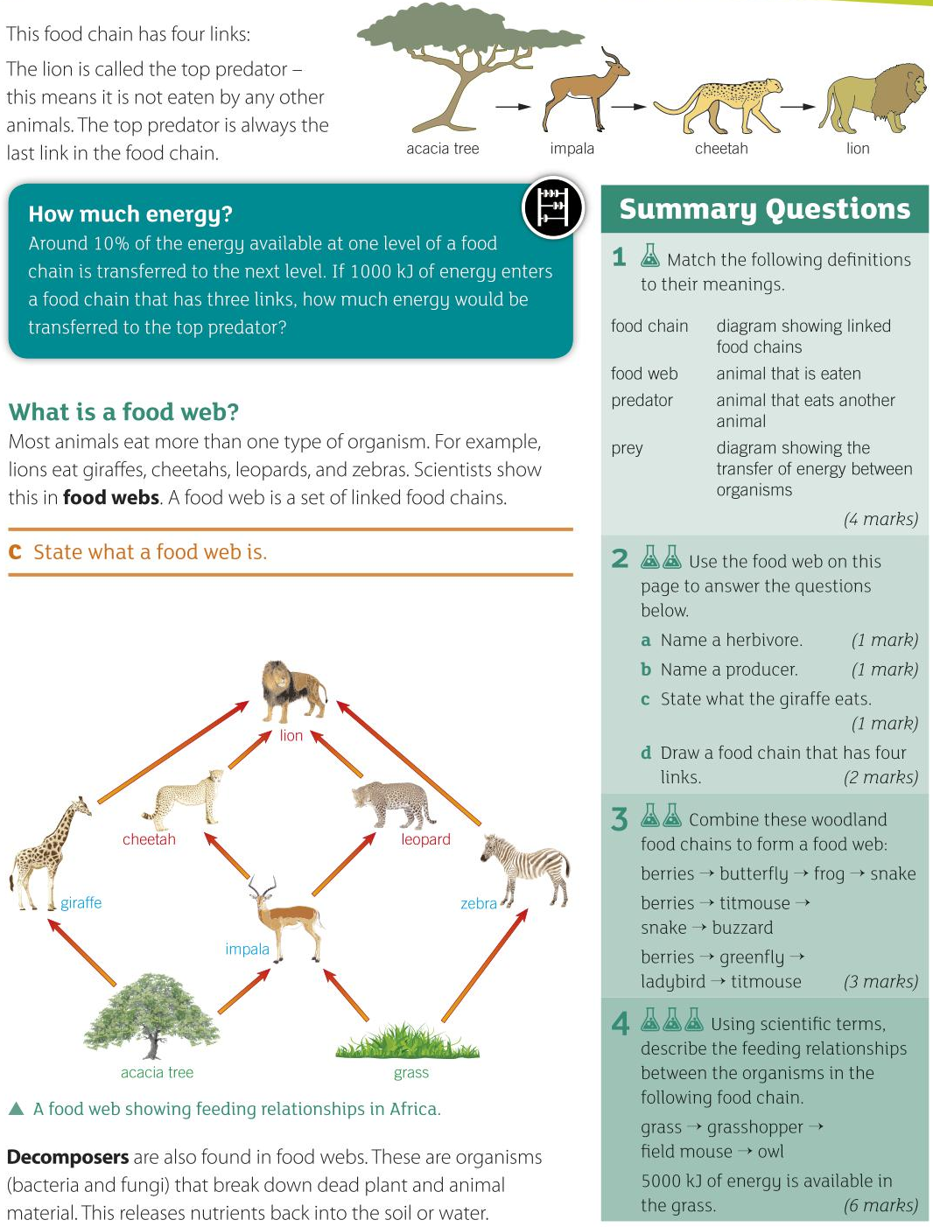

Textbook Page 3
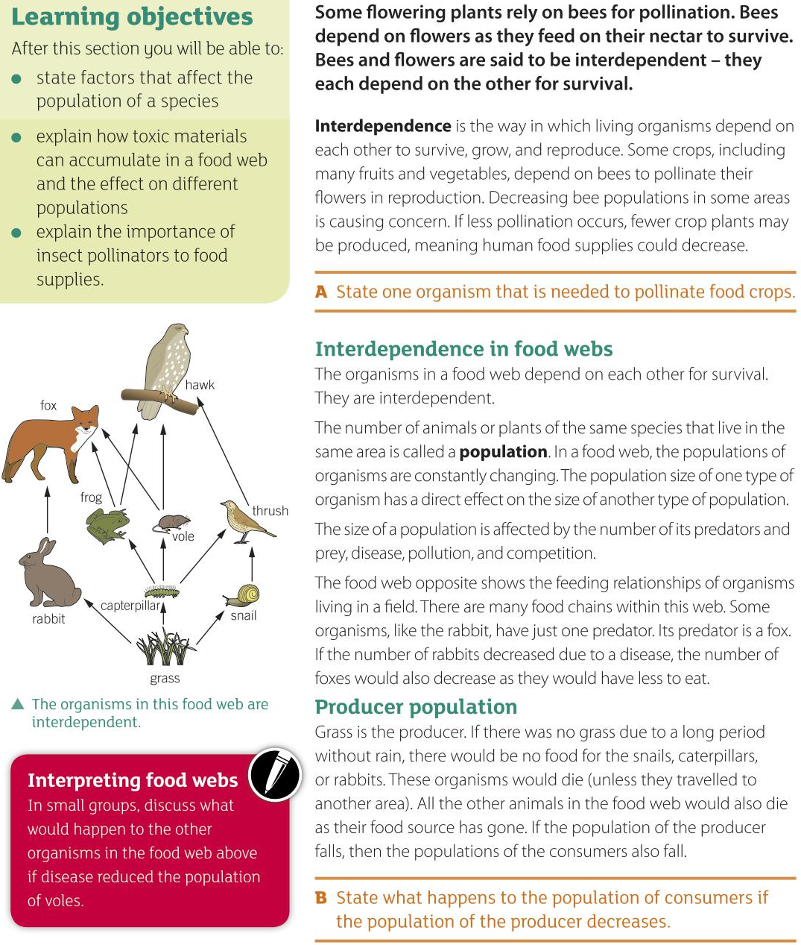

Textbook Page 4
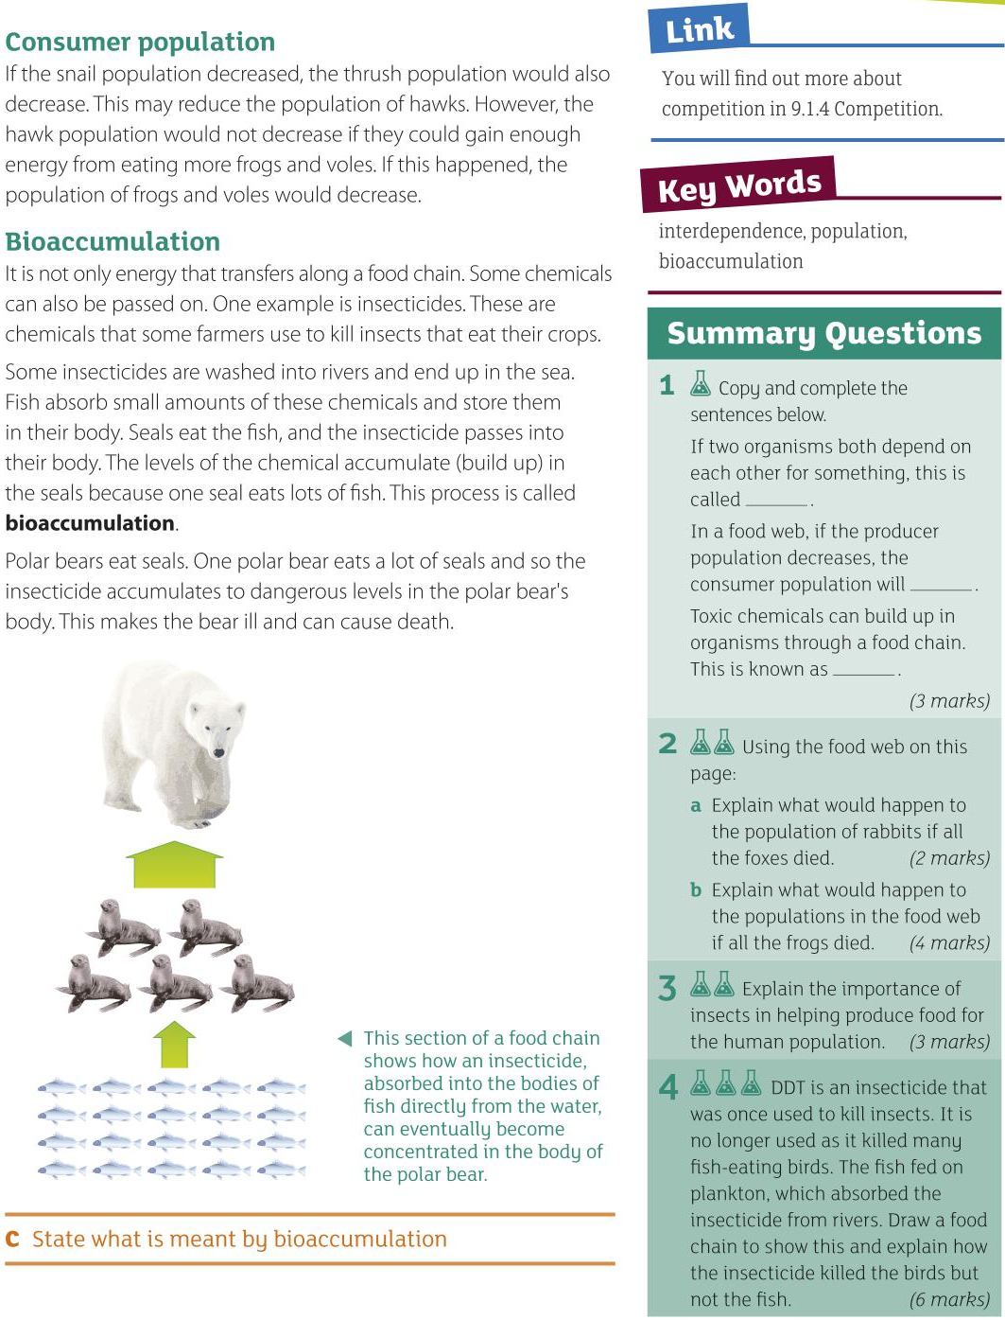

Task - Match the Term to its Definition
Match the term to its definition.
habitat
Animal that eats other animals or plants.
population
The area in which an organism lives.
bioaccumulation
A diagram that shows how food chains in
an ecosystem are linked.
Group of the same species living in an area.
food web
The build-up of toxic chemicals
inside organisms in a food chain.
decomposer
Green plant or algae that makes its own
food using sunlight by the process of photosynthesis.

consumer
A diagram that shows the transfer of energy between organisms.
producer
food chain
Organism that breaks down dead plant
and animal material so nutrients can be recycled back to the soil or water.

Task - Create a Food Web
- Cut out the cards.
- Pay attention to the info on each card – it will tell you how the web goes together.
- Use the cards to construct a food web.

Kestrel  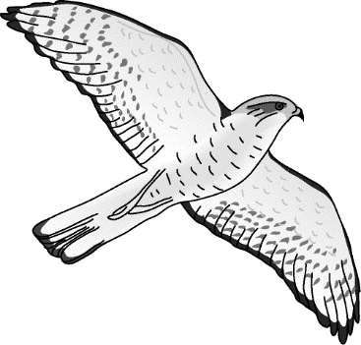  Eats: rabbit, mouse, thrush  Eaten by: no natural predators | Grass  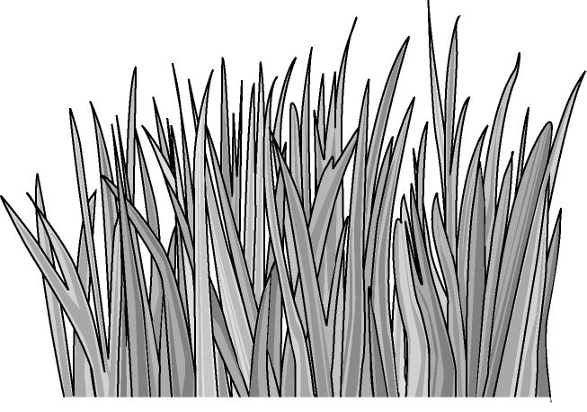  Eats: nothing  Eaten by: mouse, earthworm, rabbit | Fox  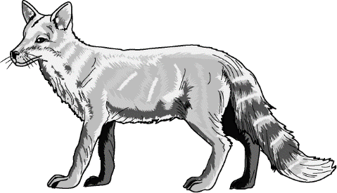  Eats: earthworm, mouse, rabbit  Eaten by: no natural predators
Rabbit  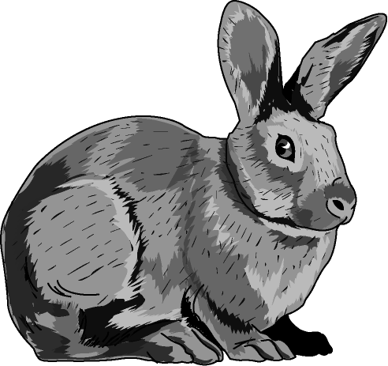  Eats: grass  Eaten by: kestrel, fox | Earthworm  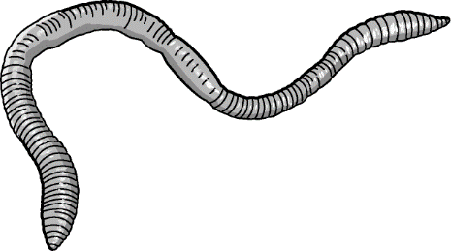  Eats: mountain ash, grass  Eaten by: mouse, fox | Mouse  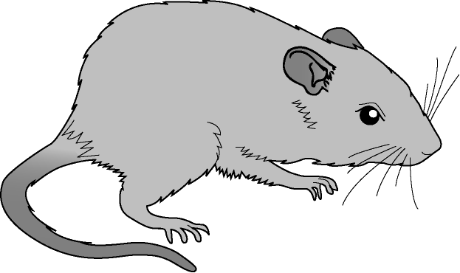  Eats: earthworm, grass, mountain ash  Eaten by: kestrel, fox
Thrush  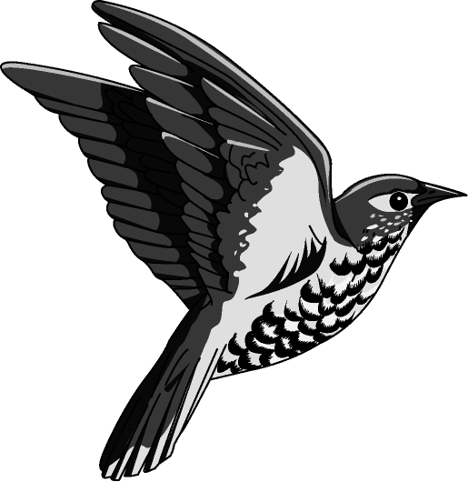  Eats: mountain ash, caterpillar  Eaten by: kestrel | Caterpillar  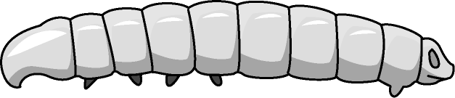  Eats: mountain ash  Eaten by: thrush | Mountain ash  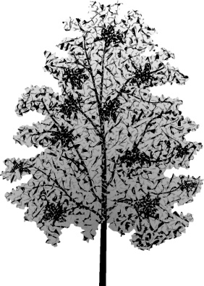  Eats: nothing  Eaten by: caterpillar, earthworm, thrush, mouse

Answers

Textbook Page 1

A It is a diagram that shows what an organism eats. It shows the flow of energy between organisms.

B A predator eats other animals, whereas prey are eaten by other animals.

Textbook Page 2

C A set of linked food chains.
How much energy? First level = 1000 kJ,
Second level = 0.1 x 1000 kJ = 100 kJ,
Third level = 0.1 x 100 kJ = 10 kJ
10 kJ would be passed to the top predator.
1 food chain – diagram showing the slow of energy through organisms
food web – diagram showing linked food chains
predator – animal that eats another animal
prey – animal that is eaten (4 marks)
2a giraffe/impala/zebra (1 mark)
b acacia tree/grass (1 mark)
c acacia tree (1 mark)
d Credit any suitable answer. For example, grass → impala → leopard → lion
(1 mark for correct order of organisms, 1 mark for arrows in correct direction)
3 1 mark for all arrows pointing in correct direction.
1 mark for two food chains correctly interlinked.
1 mark for third food chain correctly interlinked.
4 Example answers (6 marks):
Grasshopper eats grass, field mouse eats grasshopper, owl eats field mouse.
Grass is the producer. Grasshopper is the herbivore. The carnivores are the field mice and the owls.
The predators are the field mice and the owls. The prey are the grasshoppers and the field mice. The top predator is the owl.
500 kJ of energy are transferred to the grasshopper.
50 kJ are transferred to the field mouse.
5 kJ are transferred to the owl.

Textbook page 3
A bees (or any other appropriate answer).
B The population of consumers will decrease.
Interpreting food webs Credit sensible suggestions for what would happen to other organisms in the food web if disease reduced the population of frogs.

Textbook page 4
C The build-up of (toxic) chemicals through a food chain.
1 interdependence, decrease, bioaccumulation (3 marks)
2a Rabbit population would increase as it has no predators/it will not get eaten (2)
b The hawk and fox population may decrease as they have reduced food supplies.
The insect population may increase as they have fewer predators. (4 marks)
3 Any three from:
Insects act as pollinators.
This ensures seeds are produced to produce future crops.
This also ensures fruits are produced.
If insect numbers decrease, the amount of foods produced would drop. (3 marks)
4 Extended response question (6 marks). Example answer:
Insecticide runs into river. Taken up by plankton. DDT accumulates in fish when they eat the plankton. One fish eats lots of plankton, but not enough to cause death. DDT accumulates in birds when they eat the fish. One bird eats many fish. DDT level is now so high/concentrated that it causes death in the bird.

Task - Match the Term to its Definition
Food Chain - A diagram that shows the transfer of energy between organisms.
Producer - Green plant or algae that makes its own food using sunlight by the process of photosynthesis.
Consumer - Animal that eats other animals or plants.
Decomposer - Organism that breaks down dead plant and animal material so nutrients can be recycled back to the soil or water.
Food Web - A diagram that shows how food chains in an ecosystem are linked.
Bioaccumulation - The build-up of toxic chemicals inside organisms in a food chain.
Population - Group of the same species living in an area.
Habitat - The area in which an organism lives.

Task - Create a Food Web
Make sure your arrows point in the right direction as they show what is eating what.
