KS4 – Science

Tasks & Activities
Start by reading the textbook pages and answering all the questions, then try the tasks.
The answers can be found towards the end of the section.

Textbook Page 1
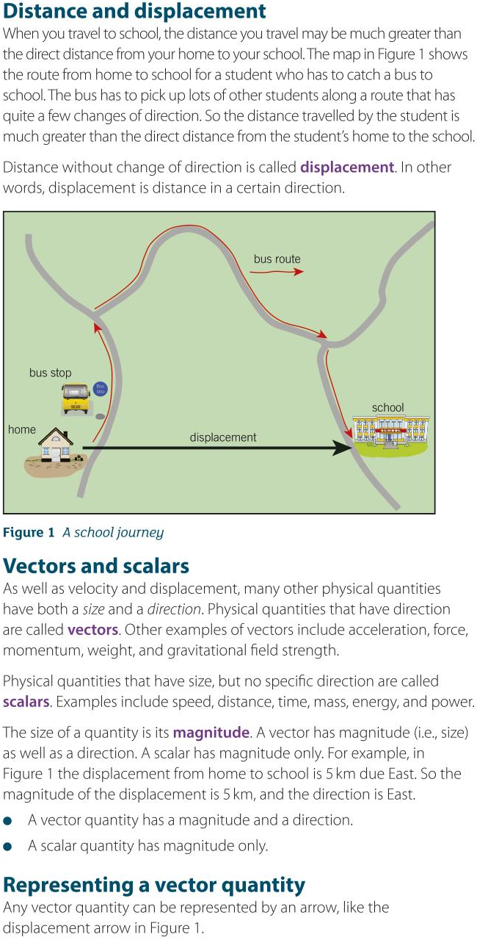

Textbook Page 2
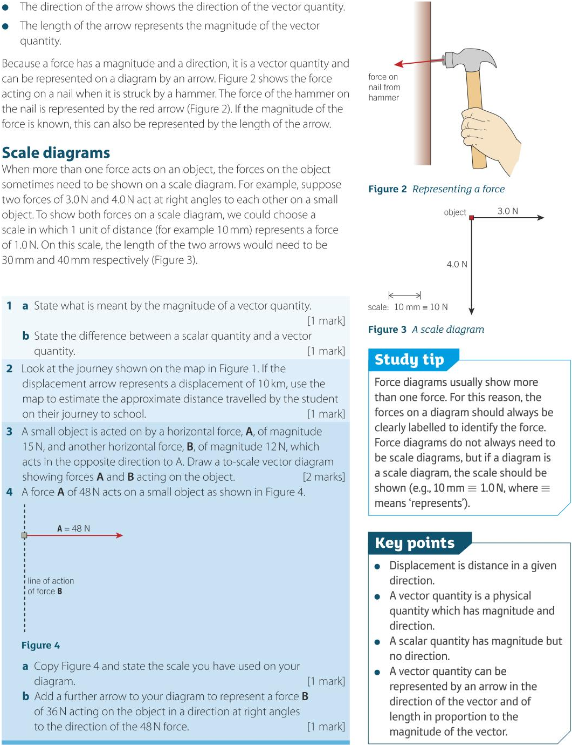

Textbook Page 3
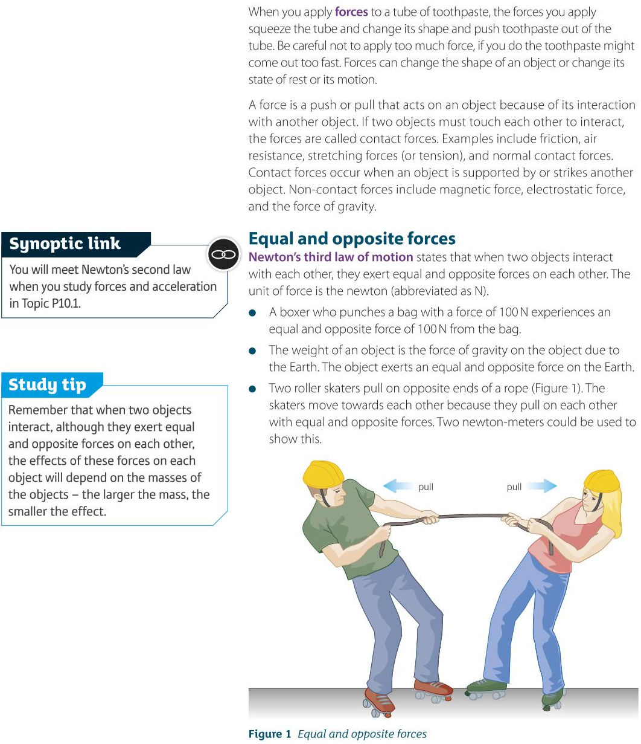

Textbook Page 4
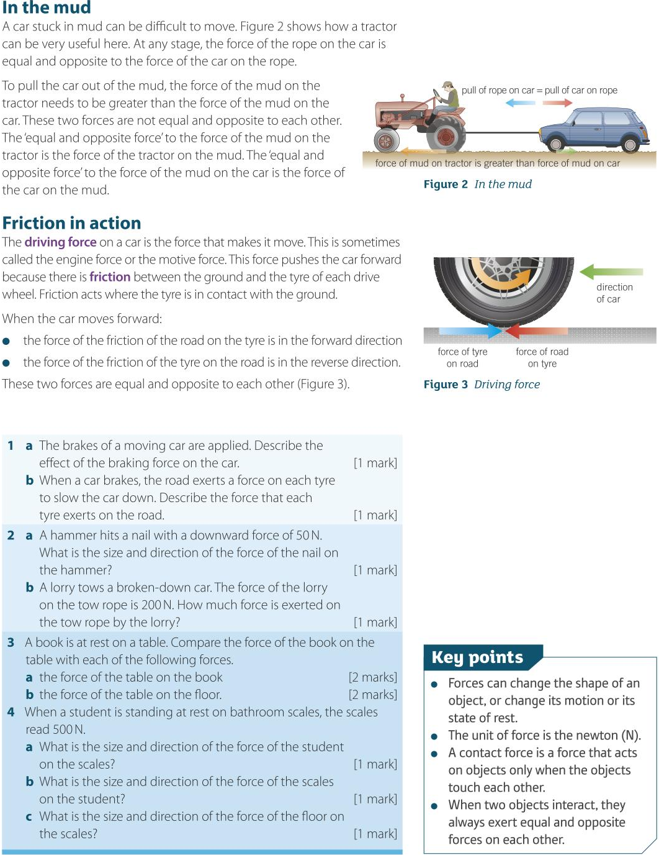

Task – Scalars & Vectors
Read textbook pages 1 & 2 carefully and then answer the questions.
- Define the terms:
  - Scalar Quantity

  - Vector Quantity

- Explain whether each of the following statements are stating vector behaviour or scalar behaviour:
  - “The body had a mass of 45 kg.”

  - “The weight of the body is due to gravity, so acts downwards.”

  - “The speed of the car was constant as it circled the roundabout.”

  - “The magnetic field lines act from the North to the South pole.”

- Explain why it is possible for a satellite orbiting the Earth to have a constant speed, but a changing velocity.

- Explain why understanding vectors is useful for:
  - Engineers & Architects

  - Professional sports people

Task – High Diving
Read carefully and then answer the questions.
High diving is the act of diving into water from extreme heights.
In 2013, at the World Aquatic Championships, a new competition was introduced – a high dive from 27 m.
The highest dive board in the Olympics is 10 m.
From this height dives can take up to three seconds, with divers reaching speeds of 90 kmph before entering the water.
In this diving competition, divers enter the water feet first because of the high risk of head injury.
The water stops the divers in less than a second and they rarely go deeper than 4 m.

- Name one contact force and one non-contact force acting on the diver as they are falling through the air. (2)

- Name one contact force and one non-contact force acting on the diver as they enter the water. (2)

- For the contact and non-contact forces you named in question 1, identify their equal and opposite force. (2)

- For the contact and non-contact forces you named in question 2, identify their equal and opposite force. (2)

- Explain why, in terms of forces, there is a risk of head injury when diving from this height. Suggest why the high divers would choose to enter the water feet first. (3)

- The text describes the diver as falling through the air for 3 seconds and then being stopped in the water in less than a second. Describe the motion of the diver as they enter the water and explain it in terms of the forces acting on them. (4)

Answers

Textbook Page 2
1 a size of quantity 1
1 b scalar has magnitude only, vector has direction too 1
2 between 20 and 21 km 1
3 scale diagram with ratio B : A = 1.25 : 1 (= 15 N / 12 N ) 1
therefore arrow for B is 1.25 times the length of the arrow for A 1
4 a a depends on 48 N arrow length: e.g., 60 mm arrow → scale 10 mm ≡ 8.0 N 1
4 b ratio B : A = 0.75 : 1 (= 36 N / 48 N ), arrow for B points downwards from
object along dashed line, arrow ∴ 0.75 times length of arrow for A 1

Textbook Page 4
1 a decelerates 1
1 b force equal and opposite to force road exerts on each tyre 1
2 a 50 N upwards 1 2 b 200 N 1
3 a forces equal in magnitude to each other and opposite in direction 1
because book presses on table and table exerts
equal and opposite force on book 1
3 b forces vertically downwards but
force of table on floor > force of book on floor 1
because floor supports weight of table and book,
table only supports book 1
4 a 500 N downwards 1
4 b 500 N upwards 1
4 c 500 N upwards 1

Task – Scalars & Vectors
1 a A scalar is a quantity that has size or magnitude but no specific direction.
1 b A vector is a quantity that has a size or magnitude and a specific direction.
2 a scalar quantity; mass has no specific direction
2 b vector quantity; weight acts downwards
2 c scalar quantity; speed may remain constant, but velocity is constantly changing as car circles the roundabout
2 d vector quantity; the field lines have a specific direction from N to S pole
3 A satellite has a constant speed because it covers the same distance per second when moving, but it has a changing velocity because the direction of motion is constantly changing. Since velocity is a vector, if the direction changes then the velocity changes.
4 a Engineers and architects need to know the forces, stresses, strains, or pressure values, and which direction they act in. These are vector quantities.
4 b Sports people may need to know the best trajectory and size of a force for throwing, aiming, jumping, kicking, etc, all of which are vector quantities.

Task – High Diving
1 Possible contact forces: air resistance, drag (allow friction), push of air on diver. (1)
Possible non-contact forces: gravity, weight, gravitational attraction of the Earth on the diver. (1)

2 Possible contact forces: drag, water pushing against diver (allow friction), push of water on diver, upthrust. (1)
Possible non-contact forces: gravity, weight, gravitational attraction of the Earth. (1)

3 Diver pushing on air and gravitational attraction of diver on the Earth. (2)

4 Diver pushing on water and gravitational attraction of diver on the Earth. (2)

5 Mark for each relevant point – maximum 3 marks
  - When divers enter the water they are pushing on the water with big force. (1)
  - The water pushes back with equal and opposite force. (1)
  - Divers want the smallest possible surface area to be presented to the water. (1)
  - If the diver enters feet-first, by the time their head enters the water, the diver has slowed down. (1)

6 Give 1 mark for each relevant point – maximum 4 marks
To gain full marks, make at least one relevant point about the motion of the diver.
  - Diver decelerates. (1)
  - From the bottom of the dive the diver accelerates upwards. (1)
  - Once in the water the diver experiences upthrust. (1)
  - This force is in an opposite direction to the weight of the diver. (1)
  - Upthrust in the water is greater than weight. (1)
  - The resultant force is upwards. (1)
  - The drag force in water greater than drag force in air. (1)

